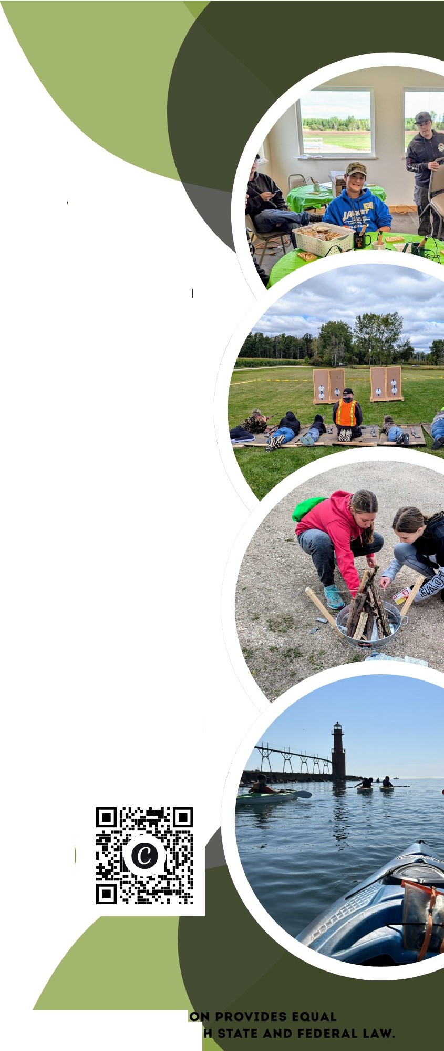
Extension
UNIVERSITY OF WISCONSIN-MADISON
- KEWAUNEE COUNTY

2026 OUTDOOR
'

ADVENTURE DAY
Unleash your inner explorer at the Kewaunee County 4-H Outdoor Adventure Day, where the thrill of the wild meets the beauty of nature.

Workshop choices include kayaking, fire building, leathercraft, woodworking, intro to fishing, turkey call, hunter safety, air rifle, flower crafts, plaster tracks, wood burning, bee keeping, and mosaics.
October 3, 2026 8:45AM-2:00PM
Black Ash Gun Club
E5108 W. Wilson Rd., Algoma

Designed for members and friends in grades 6-13.
Cost: $1O per person. Please see full brochure for more infromation
FYI.EXTENSION.WISC.EDU/
KEWAUNEE4H
" April: 920-660-2764
" Debbie: 920-360-0702
THE UNIVERSITY OF WISCONSIN-MADISON DIVISION OF EXTENSI OPPORTUNITIES IN EMPLOYMENT AND PROGRAMM NG IN COMPLIANCE WIT

Workshop Choices
Sessions: You will choose your top 6 choices. Spaces are limited and filled on a first come, first filled basis. Please note: Kayaking will take two session times.

Double Length Session (110 minutes long)
  - Kayaking Part 1 and 2 - (must take both parts 1 and 2, both in the morning or both in the afternoon) - Learn kayaking basics. You will port-in near Algoma and make your way down Silver Creek. All participants will be required to wear a life jacket during kayaking. If you sign-up for this session and have your own life jacket, we encourage you to bring it.

Regular Length Sessions (50 minutes long)
  - Suet Feeder and Suet: Wood working. Make your own suet feeder. Will also make the suet for the feeder.
  - Leathercraft - Learn the basics of leather craft and make a project to take home.
  - Woodburning - Learn how to wood burn and make your own project to take home.
  - Fire Building: Learn about different fire structures. Compete with your fire building skills. Enjoy a fire-cooked treat.
  - Turkey Call, Hunter Safety, Tracking: Make a turkey call, learn about hunter safety, and deer habitat and population.
  - Flower Art: Become nature’s Picasso when you create multiple masterpieces with nature’s beauty. Create a resin project using dried flowers, and other flower craft projects.
  - Fishing 101: Learn about fishing safety, equipment, art of casting, tying knots, and which lure to use for the fish you want to catch. Workshop choice does not include water.
  - Mosaics: Use glass and stone to create a one-of-a-kind artwork.
  - Plaster Tracks: Make a cast from a mold of your favorite woodland animal track.
  - Air Rifle: Learn about air rifle safety and target practice.
  - Pet a Bee: Learn all about bee keeping, harvest honey, and pet a drone bee.
THANK YOU!
- Black Ash Gun Club for the use of the facility and support from members
•
•
Norb and Barb Yogerst, and Doug Thompson
Kewaunee County 4-H Leaders Association
- All the adult and youth volunteers that make this day possible

Event Notes
- Pre-registration: You must be pre-registered and payment must be received to attend Outdoor Adventure Day.
See below for more information on how to register.
- Registration Deadline: Register by September 14, sessions are first come, first fill.
- Event location: This takes place at Black Ash Gun Club, E5108 W Wilson Rd., Algoma, WI 54201 that has indoor work spaces and bathrooms. Some of the activities will take place on uneven terrain or spots with mud/water. Participants may go into fields or wooded areas. Please wear appropriate footwear.
- Cost: $10.00 for the entire day (including materials, lunch and snacks)
- Parents are not required to stay but we ask that you provide current emergency contact information and fill out the health form completely.
- Check In/Check Out: Check-in and instructions, 8:45-9:00 am. Check out will begin at 2:00 pm. Parents need to sign their child(ren) out at the end of the day.
- Program Accommodations Available: Requests for reasonable accommodations for disabilities or limitations should be made prior to the date of the program or activity for which it is needed. Please do so as early as possible prior to the program or activity so that proper arrangements can be made. In certain situations,
information related to requests may be shared with staff or units necessary to help coordinate an appropriate accommodation.

Questions?
Please contact Debbie Olson at (920) 360-0702/daomjb@gmail.com or April Smith at (920) 660-2764/aak0306@yahoo.com.

Black Ash Gun Club—E5108 W Wilson Rd., Algoma, WI 54201

How to register for Outdoor Adventure Day:
Registration: Fill out and return a paper copy registration form, $10 non refundable payment, and health form to Kewaunee County 4-H, 625 3rd St., Luxemburg, WI 54217. You will receive an email confirmation once registration is received and confirmed.
Payment: Cash or check accepted. Please make checks payable to Kewaunee Co. 4-H Leaders Association. Registration will be complete once payment is received.

In the operation of the Outdoor Adventure Day program, discrimination on the basis of age, race, color, creed or religion,
national origin, ancestry, gender, sexual orientation, marital or parental status, pregnancy, veterans' status, arrest or non-job or program related conviction record or qualified disability is prohibited.


Youth Event Health Form | Event Name:
 | Dates:

Youth Name: |  | Birth date | / / | Age on 1st day of event | Sex: | Male Female
Custodial Parent/Guardian (or spouse) |  |  |  | E-mail address:
Phone Numbers: | Home ( ) - | Work ( ) - |  | Cell phone ( ) -
Home address:
 | Street |  | City | State |  | Zip

Second parent/guardian  and/or emergency contact: | Phone: | Home ( ) -
 |  | Work ( ) -
Address:
Street | City | State | Zip

Yes | No | Health Conditions (check) | Yes | No | Allergies (check) | List specifics
 |  | Asthma |  |  | Insect stings
 |  | Diabetes |  |  | Foods
 |  | Epilepsy |  |  | Medications
 |  | Psychiatric |  |  | Other
 |  | Cognitive/Developmental |  |  | Do any allergies require an EPIPEN injection?
 |  | Any dizziness, light-headedness or fainting associated with exercise within the past year? |  |  | Is insulin required and carried by youth?
 |  | Any unexplained, rapid or irregular heart beat within the past year? |  |  | Is an inhaler required and carried by youth?
 |  | A physician has sometime denied or restricted participation in sports due to a heart problem. | Date of last Tetanus booster: (mm/dd/yy)

Name of Insurance Co.: Policy #: Medications camper will be taking during event/camp:
Medication #1 | Reason | Dosage (mg) | Times of day given | Prescribing Physician & Phone Number
Describe side effects (mood/behavior changes, upset stomach, diarrhea):

List any special instructions or additional information regarding the medication that would be helpful to the health care staff:


The University of Wisconsin–Madison Division of Extension provides equal opportunities in employment and 1

programming in compliance with state and federal law.
Last updated August 2025

UW – Madison Extension
Youth Event Health Form (Continued)
Participant Name: Parent/Guardian Signature:

Medication #2 | Reason | Dosage (mg) | Times of day given | Prescribing Physician & Phone Number
Describe side effects (mood/behavior changes, upset stomach, diarrhea):

List any special instructions or additional information regarding the medication that would be helpful to the health care staff:

Medication #3 | Reason | Dosage (mg) | Times of day given | Prescribing Physician & Phone Number
Describe side effects (mood/behavior changes, upset stomach, diarrhea):

List any special instructions or additional information regarding the medication that would be helpful to the health care staff:
Programs may have limited over-the-counter medications available. Select medications that can be administered, if available.

Acetaminophen (Tylenol): |  |  | Yes | No
Hydrocortisone (anti-itch) cream: |  |  | Yes | No
Benadryl: | Yes | No
Ibuprofen: | Yes | No

Accommodations
Does the youth require an accommodation to participate in this event? Please describe:
Please describe any limitations or restrictions regarding the youth’s participation:
Is there any other information you want to share?

The University of Wisconsin–Madison Division of Extension provides equal opportunities in employment and 2

programming in compliance with state and federal law.
Last updated August 2025

CONSENT FOR MEDICATION ADMINISTRATION AND MEDICAL TREATMENT

TO THE PARENT(S) OR LEGAL GUARDIAN:
If your son, daughter, or ward will be under the age of 18 while participating in a University of Wisconsin – Madison Division of Extension event/camp/program, it is event/camp/program policy to secure your consent for medication distribution and for the use of medical devices. The medication or medical device must be administered by designated event/camp/program health staff with the exception that a limited amount of medication for life-threatening conditions may be carried and administered by my son/daughter/ward (i.e. bee sting kit, inhaler, insulin syringe).

It is event/camp policy to secure your consent for medication distribution and for the use of medical devices by signing below.
Please check all that apply:
 | Yes | No
 |  |  | Medication(s) has been brought to event/camp. | 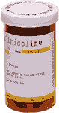
Prescription medication(s) has been brought to event/camp. All prescription medication must be in the original medicine bottle and labeled with the youth participant’s name, doctor’s name, medication name, dosage, prescription number, date prescribed, and instructions. Also, information
about any prescription medications must be provided in writing to event/camp health staff with the information requested in the later section of this form.
Over-the-counter medications have been brought to event/camp and may be administered by event/camp health staff as needed. All over-the-counter medications must be labeled with the youth
participant’s name, medication name, dosage and instruction.
If your son, daughter, or ward will be under the age of 18 years while at the event/camp, it is our policy to secure your consent for all of the following. By signing below,

- I am giving my consent in advance for medical treatment at an appropriate medical facility in case of illness or injury.

- I am stating that I am aware of and accept the risk inherent in the program activity.
- I attest that all information on this form is correct and up-to-date, and that I will provide any and all significant material, and important changes to any information in this form to event/camp staff no later than check-in.
- I agree to hold harmless and indemnify the Board of Regents of the University of Wisconsin System, and the University of Wisconsin – Madison Division of Extension, their officers, agents, and employees from any and all liability, loss, damages, costs, or expenses which are sustained, incurred or required arising out of the actions of my son, daughter or ward in the course of the event/camp.

Participant Name (Please Print)
SIGNATURE OF PARENT OR LEGAL GUARDIAN |  | Date

This is the approved health form for 4-H events and camps.
The University of Wisconsin–Madison Division of Extension provides equal opportunities in employment and 3

programming in compliance with state and federal law.
Last updated August 2025



Video, Image, Testimonial Consent Form
Adult participants:
I recognize and acknowledge that the University of Wisconsin may record my participation and appearance on any recorded medium including, but not limited to video, audio, photos (collectively, “recordings”) for use in any form (including, but not limited to print, websites, blogs, internet, and social media). I authorize such recording and release the University of Wisconsin to use my name, likeness, voice, and biographical material to exhibit or distribute such recordings in whole or in part without restrictions or limitations for any educational or promotional purpose. I further authorize the University to distribute such recording to third parties (e.g., newspapers) and release such third parties to use my name, likeness, voice, and biographical material to exhibit or distribute such recordings in whole or in part without restrictions or limitations for any educational, promotional, editorial, or news reporting purpose.

Name

Signature Date
Minor participants:
I recognize and acknowledge that the University of Wisconsin may record my child's participation and appearance on any recorded medium including, but not limited to video, audio, photos (collectively, “recordings”) for use in any form (including, but not limited to print, websites, blogs, internet, and social media). I authorize such recording and release the University of Wisconsin to use my child's name, likeness, voice, and biographical material to exhibit or distribute such recordings in whole or in part without restrictions or limitations for any educational or promotional purpose. I further authorize the University to distribute such recording to third parties (e.g., newspapers) and release such third parties to use my child’s name, likeness, voice, and biographical material to exhibit or distribute such recordings in whole or in part without restrictions or limitations for any educational, promotional, editorial, or news reporting purpose.

Name of minor

Name of guardian or parent

Signature Date

An EEO/AA employer, University of Wisconsin-Madison Division of Extension provides equal opportunities in employment and programming, including Title VI, Title IX, the Americans with Disabilities Act (ADA) and Section 504 of the Rehabilitation Act requirements. 7-18-2023

Outdoor Adventure Day 2026 Registration

Child’s Name

Age/Grade

Parent/Guardian Name

Parent/Guardian Phone Number

Parent/Guardian Email Address

Class Selections (place in order of top choice down, with #1 being your top pick)
1.

2.

3.

4.
5.

6.

If going Kayaking, do you have your own life jacket you will bring? YES NO
Note: Kayaking is two sessions so you will not get as many classes. We will try to put you in your top choices for classes, but they fill on a first come/first serve basis.

Any extra notes or concerns:

Allergies:

Accommodations needed:

**Send this form along with Youth Health Form and payment no later than September 14 to: Kewaunee County 4-H
Outdoor Adventure Day 625 3rd Street
Luxemburg, WI 54217

