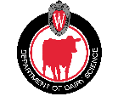
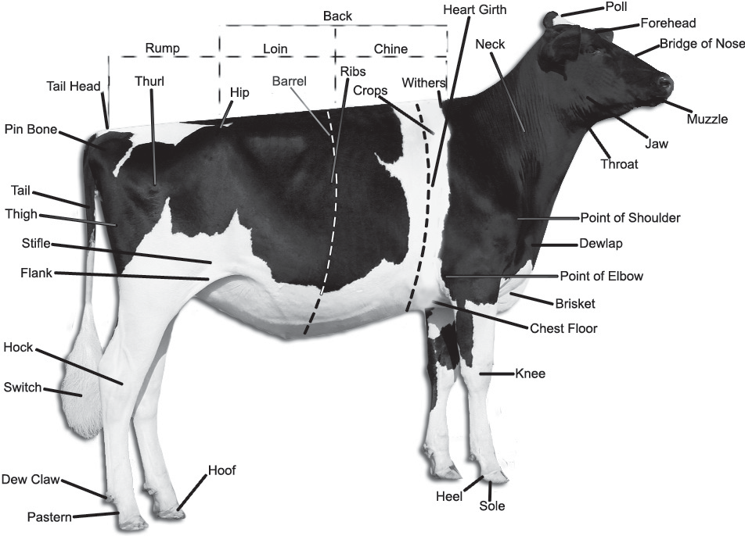
Calf & Heifer SCORE CARD

GENERAL APPEARANCE
35
Attractive individuality and harmonious blending of parts, with the exception of rear feet and legs, is evaluated. Listed in priority order, the descriptions of the traits to be considered are as follows:
Style and Balance: Harmonious blending of parts; proportionate height, length and depth. Rump: long and wide throughout with pin bones slightly lower than hip bones. Thurls wide apart and centrally placed between hip bones and pin bones. Tailhead set slightly above and neatly between pin bones. Tail free from coarseness. The vulva is nearly vertical. Back: straight and strong; Loin: broad, strong and nearly level; slight arch preferred. Front End: adequate constitution with front legs straight, wide apart and squarely placed. Shoulder blades and elbows set firmly against the chest wall. The crops should have adequate fullness. Breed Characteristics: clean cut head, broad muzzle with large, open nostrils, and strong jaw.

DAIRY CHARACTER
Evidence of potential milking ability is evaluated. Major consideration should be given to general openness and angularity without 25
weakness, flatness of bone, and freedom from coarseness. Listed in priority order, the descriptions of the traits to be considered are as
follows:
Ribs: wide apart. Rib bones wide, flat, deep, and slanted toward the rear. Thighs: lean, incurving to flat and wide apart from the rear. Withers: sharp with chine prominent. Neck: long, lean and blending smoothly into shoulders; clean cut throat, dewlap, and brisket. Skin: thin, loose and pliable.
Allowance should be made for winter and fall yearlings to carry more condition as they approach calving.

REAR FEET AND LEGS
20
Feet and rear legs are evaluated. Evidence of mobility is given major consideration. Listed in priority order, the descriptions of the traits to be considered are as follows:
Movement: The use of feet and rear legs, including length and direction of step. When walking naturally, the stride should be long and fluid with the rear feet nearly replacing the front feet. Rear Legs-Side View: Moderate set (angle) to the hock. Rear Legs-Rear View: Straight, wide apart with feet squarely placed. Feet: Steep angle and deep heel with short, well-rounded closed toes. Thurl Position: Near central placement between the hip and pin bones. Hocks: Adequate flexibility with freedom from swelling. Bone: Flat and clean with adequate substance. Pasterns: Short and strong with some flexibility, having a moderate, upright angle.

SIZE
20
Growth, vigor and good health are evaluated. Major consideration should be given to height at the point of wither. The description of the trait to be considered is as follows:
Stature: height including length in the leg bones with a long bone pattern throughout the body structure; height at withers and hips should be relatively proportionate. Barrel: long, deep and wide; depth and spring of rib increasing toward the rear with a deep flank. Chest: deep and wide floor with well sprung fore ribs blending into the shoulders.

Copyrighted by Ted Halbach & the University of Wisconsin-Madison Dairy Cattle Judging Team, 2010. Revised and copyrighted 2011.

