Activity: Parts of a Cow
Label all of the parts of the cow.
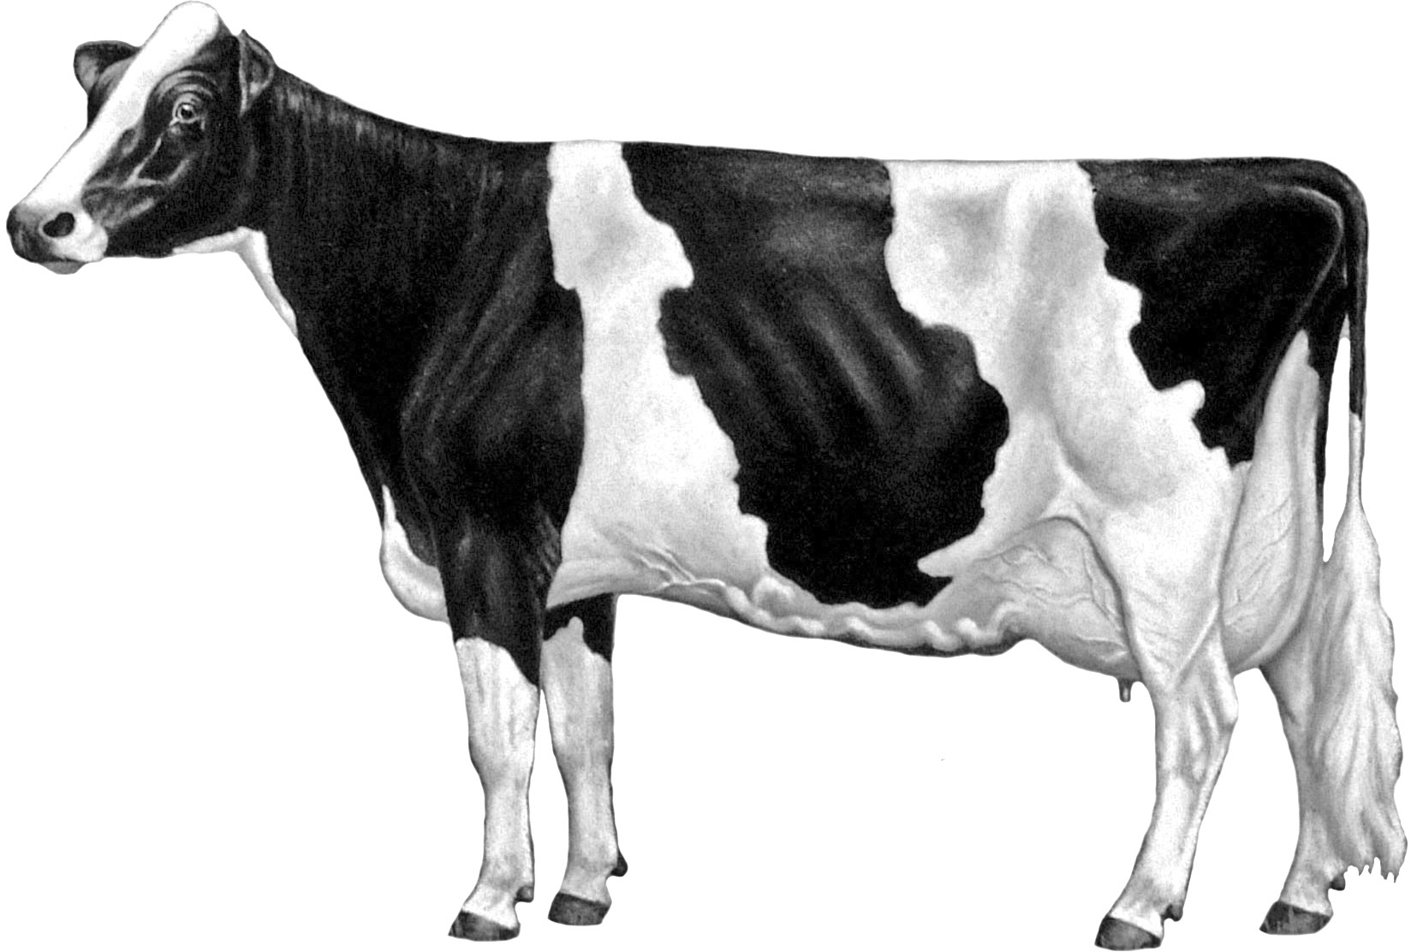





1
2 44
42
41
40
43
39
38
37 36 35 34 33 32
3

31

Back
Barrel
Bridge of Nose
Brisket
Chest Floor
Chine
Crops
Dew Claw
Dewlap
Flank
Fore Udder

4 5 6

7
8
9

10
11
30

29

28
27
26

25

15 24
16 17

Fore Udder Attachment
Forehead
Heart Girth
Heel
Hip
Hock
Hoof
Jaw
Knee
Loin

12

13

14

Point of Shoulder Switch

18 19 23

22

21

Mammary Veins Poll Tail
Milk Wells Rear Udder Tail Head
Muzzle Rear Udder Attachment Teats
Neck Ribs Thigh
Pastern Rump Throat
Pin Bones Sole Thurl
Point of Elbow Stifle Withers
20

SOURCE: Dairy Judging
©2013 Holstein Foundation, Inc.
www.holsteinfoundation.org

