Activity: Parts of a Cow
Label all of the parts of the cow.
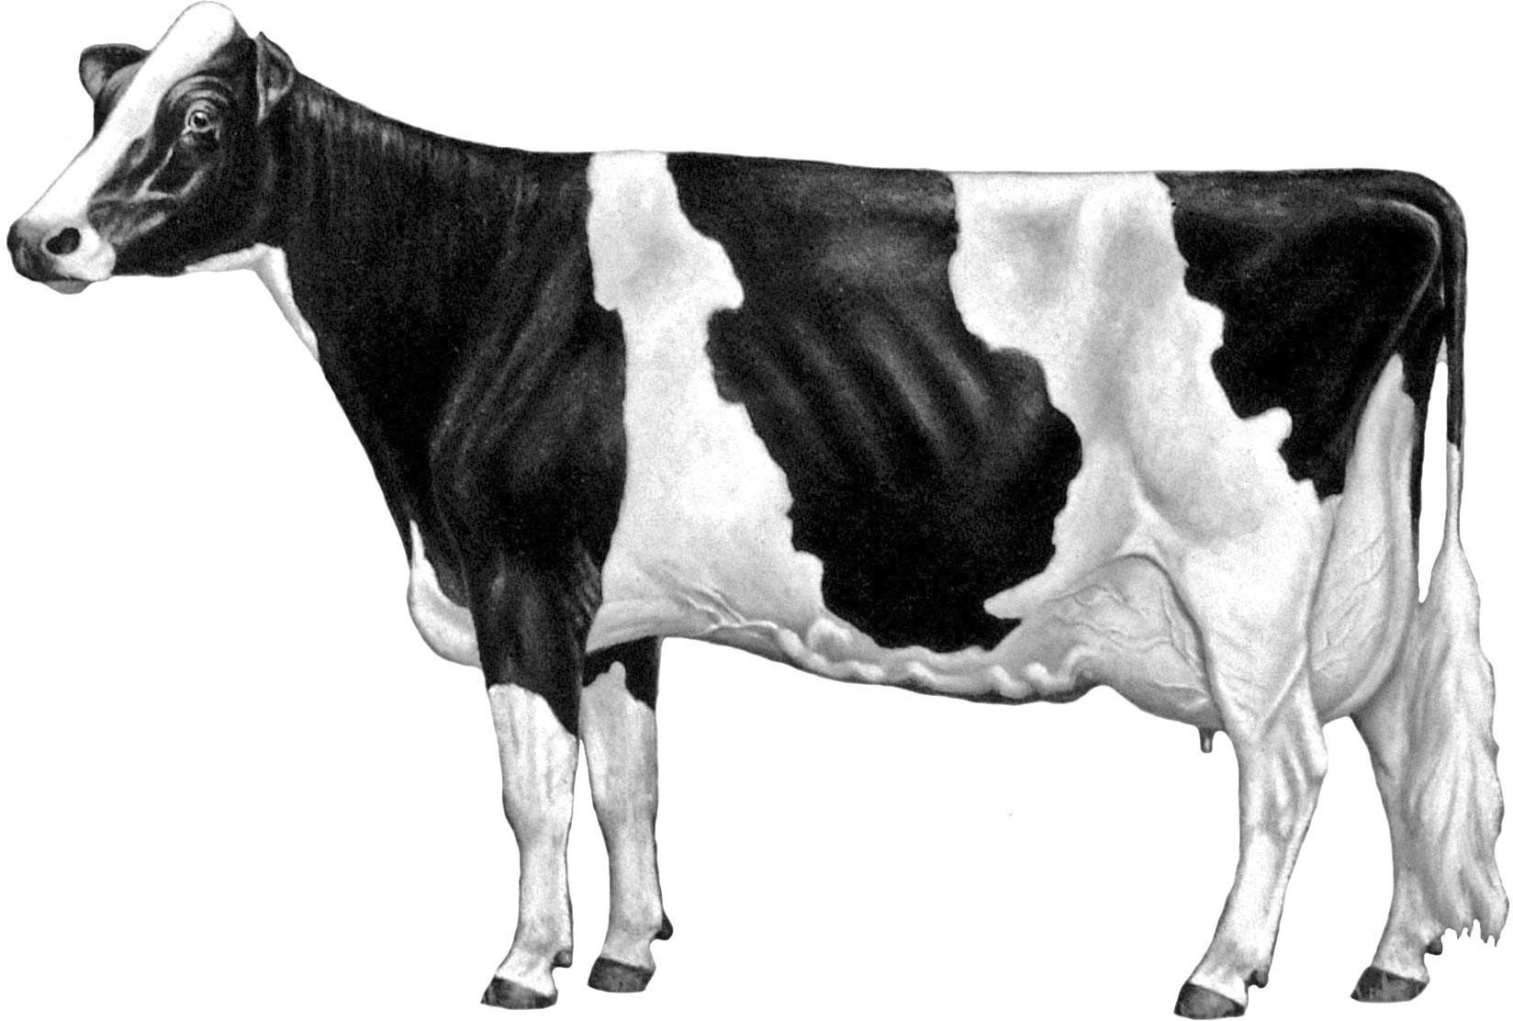



















1
2 44
42
41
40
39 43
38
3 37 36 35 34 33 32
31

44 Back
35 Barrel
3 Bridge of Nose
10 Brisket
11 Chest Floor
41 Chine
37 Crops
22 Dew Claw
9 Dewlap
26 Flank
18 Fore Udder

4 5 6

7
8
9

10
11
30

29

28
27
26

25

15 24
16 17

17 Fore Udder Attachment
2 Forehead 12
39 Heart Girth
13 Heel
34 Hip
24 Hock 13
20 Hoof
18 19 23

5 Jaw
12 Knee
14 22
21
42 | Loin | 7 | Point of Shoulder | 23 | Switch
16 | Mammary Veins | 1 | Poll | 30 | Tail
15 | Milk Wells | 25 | Rear Udder | 32 | Tail Head
4 | Muzzle | 29 | Rear Udder Attachment | 19 | Teats
40 | Neck | 36 | Ribs | 28 | Thigh
21 | Pastern | 43 | Rump | 6 | Throat
31 | Pin Bones | 14 | Sole | 33 | Thurl
8 | Point of Elbow | 27 | Stifle | 38 | Withers

20

SOURCE: Dairy Judging
©2013 Holstein Foundation, Inc.
www.holsteinfoundation.org

